Tweets “liked” by @CaraMund

- @CNN: As First Lady of the United States, and the first Black person to serve in the role, Obama “has emerged as one of the most influential and iconic women of the 21st century,” a statement from the National Women’s Hall of Fame says. (3/9/21)
- @kerrywashington: Let’s not let this impeachment totally district us from the fact that in 6 days…it will be Madame Vice President @kamalaharris (1/14/21)
- @joebiden: America is so much better than what we’re seeing today (1/6/21)
- @hleveyfriedman: I am weeping for the nation I love. #peacefultranstitionofpower (1/6/21)
- @TODAYShow: The mayor of Washington, DC has declared today Dr. Anthony Fauci Day. The infectious disease expert, a longtime DC resident, turns 80 on Christmas Eve. (12/24/20)
- @KateBennett_DC: Number of people who have texted me to ask what was running down Rudy’s face: 12 And let me say I am honored to be the person people turn to in moments like that. Hi I’m Kate. (11/19/20)
- @weijia: Finally. {With photo of Anthony Fauci behind WH Briefing Room podium} (11/19/20)
- @hleveyfriedman: Finally. Relief. I. Can. Breathe. (11/7/20)
- @hleveyfriedman: This is pretty much all I can comment on today… North Dakota Republican David Andahl, who died of covid-19, wins election (11/4/20)
- @CaressedxDesign: I was less nervous competing at Miss America (Election Day 11/3/20)
- @AOC: If someone told me 3 years ago, while I was still waitressing to help my family stay afloat, that in a few short years an unhinged President of the United States would be repeatedly saying my name at the 2020 debate, I would’ve brought them some water and told them to sober up. (10/22/20)
- @katebennett_DC: I appreciate the matching mask on @DrBiden (10/22/20)
- @TVLine: #SNL Premiere: Kate McKinnon Pays Tribute to Ruth Bader Ginsburg (10/4/20)
- @dkitzoff: Kate McKinnon pays a silent tribute to Justice Ruth Bader Ginsburg on tonight’s @nbcsnl (10/4/20)
- @clarabellum: Today I learned that you either grow up to be an Amy Coney Barrett Kappa Delta or a Christine Blasey Ford Kappa Delta (9/28/20)
- @Kassting: She was the first, but certainly not the last. #trailblazer @RIPRBG (9/18/20)
- @bb21_sam: If you ask me, Nurses and Doctors that helped during Covid-19, should have their student debt cleared out just out of pure charity from the multi million dollar universities (8/2/20)
- @KateBennett_DC: Dr. Fauci throwing out the first pitch @nationals Opening Day on Thursday (7/20/20)
- @ABC: Washington, D.C., Mayor Muriel Bowser officially named 16th Street in front of the White House “Black Lives Matter Plaza”, along with a new street sign installed, Boswer tweeted. (6/5/20)
- @KateBennett_DC: As one of my colleagues just noted, what we really needed this week was a man telling a woman to smile. (RT of DJT and Melania interaction on 6/2/20)
- @NYGovCuomo: People will die if we get cocky about reopening. To those who are upset about our careful approach – don’t blame your local official. Blame me. (4/22/20)
- @TheView: Rep. @AOC says Sen. Sanders inspired her to run for office and explains why she’s endorsing him: We want to talk about healthcare… a living wage… women’s rights… he did this when it was least convenient.” “He was fighting for these things before I was even born.” (2/19/20)
- @Georgianaplatt: Don’t think I have ever been on a flight when EVERYONE is watching the same thing (except long ago when you had no choice) #ImpeachmentHearing #constanttraveler #friendlyskies #ambassadoryovanovitch (11/15/19)
- @libbyschneider: A year ago yesterday. Working for @HeidiHeitkamp will always be one of the highlights of my career and this day tops the list of reasons why. (RT of a video of Heidi Heitkamp announcing she will vote against Supreme Court Justice Amy Coney Barrett 9/16/19)
- @AOC: That’s okay – I’ll fight for their right to healthcare anyway. (QT of tweet stating “AOC sucks!”: Donald Trump Jr. points his father’s followers to a new villain, and a new rallying cry” 3/29/19)
- @thewayoftheid: “Does this Presidential candidate spark joy”(1/21/19)
- @joeanthony49: One thing that I have learned is that we really do not know what is going on in the halls of government. They do not send a memo to the people. Which media outlet is honest and accurate? (1/18/19)
- @Prof_Kennedy: This certainly clarifies — thank you @SenatorHeitkamp for your courageous stand for the integrity and decency of our US political system. (Link to HH no on Kavanaugh) I have met other strong women from North Dakota, including @CaraMund. You both represent your state with dignity (10/4/18)
- @MrFilmkritik: Trump wants you to believe that Brett Kavanaugh’s calendar from 1982 is real, but Obama’s birth certificate is fake. (9/23/18)
- @YousefMunayyer: What is weirder, keeping a detailed calendar as a 17 year old or hanging on to your high school calendars for 40 years (9/23/18)
- @KateBennett_DC: I feel like this week is going to teach us a lot about middle-aged men and their treatment of women, both in the past and the present (9/17/18)
- @SenatorHeitkamp: This evening I met with President Trump at @WhiteHouse. As I said, if the President wants to meet with me, I’m ready to participate and advocate for North Dakota. And that’s exactly what happened today. (6/28/18)
- @HeidiHeitkamp: Thank you to everyone who came out to vote yesterday. I’m so honored to win the primary – but we’re not done yet. Join the team: heidifornorthdakota.com/volunteer (6/13/18)
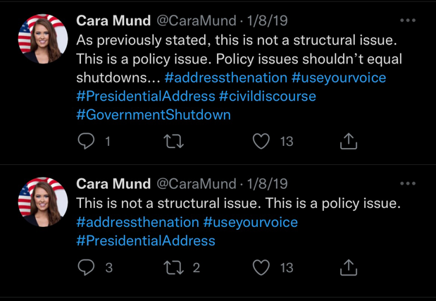
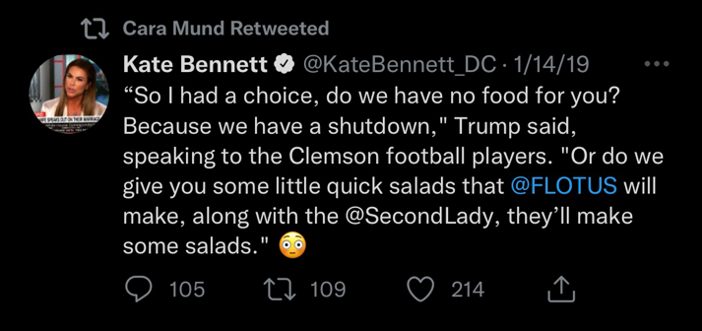
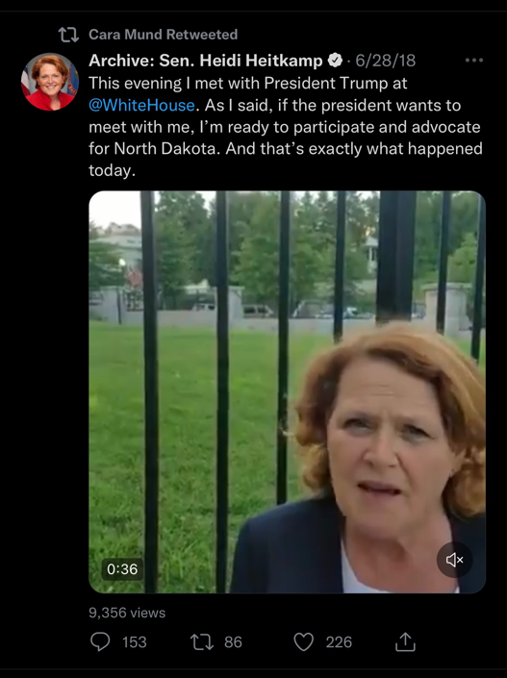
- @Prof_Kennedy: One can also credit the good influence of @BrownUniversity. Grad Cara Mund current @MissAmerica

